BUENOS AIRES, June 24th, 2012.

DECLARATION

The Argentine Grand Lodge of Free and Accepted Masons has always followed with proper care and attention, the development of its international relations within the limits of its most strict observance of the ancient landmarks, usages and customs of ancient and prestigeous universal masonry.

Since its foundation in 1857, its members collaborated with the government and the country's development, and 14 brother masons were presidents of the Nation in the years of major splendour and growth in the country.

From the beginning Argentine Masonry was part of the group of Grand Lodges who united in an effort to create and develop the Interamerican Masonic Confederation, ( C. M. I. ) body which, after 65 years of hard work brought together more than 70 Regular Masonic Grand Lodges.

However, it also had outstanding members who withdrew from its landmarks, and the close relationship of some of them with the “Propaganda Due” Lodge was detrimental to the institution, and it took many years to recover its prestige and grow in membership and citizenship participation as it has been doing in the last few years.

In its international relations it always tried to establish relationship with those Grand Lodges which strictly observed the ancient usages and establish customs of the Order, with reason preminence as a guide and motive for its development.

In this respect it always considered itself a friend of the Grand Lodge of France as it knew they shared ideals and procedures. As soon as it noticed that the National Grand Lodge of France withdrew from the landmarks, accepted by

regular masonry, it did not doubt in severing its relationship as the regretable memories of what happened with the P. 2 Lodge, proved the mistaken policy the present leaders imposed in the National Grand Lodge of France.

Today important european and world wide Grand Lodges have also understood that the Grand Lodge of France can be the means by which to establish harmony between all French masons within the most strict observance of the ancient landmarks according to the Basel Declaration (10th June 2012) and of the Council Declaration of the Federal Grand Lodge of France (13th June 2012), and pray for a meeting in order to establish an agreement between all the masonic leaders of the world that will permit mutual recognition between Regular Grand Lodges and the ancient and centenary Grand Lodge of France, and by doing this bring the normalization of all French Brethren of good will, united under one flag; that of universal and regular masonry which continues working throughout the ages to the glory of the G.A.O.T.U.

Sincerely and fraternally,

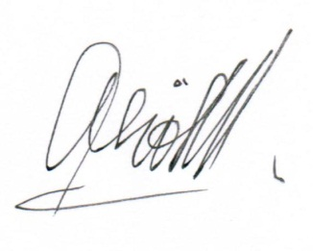
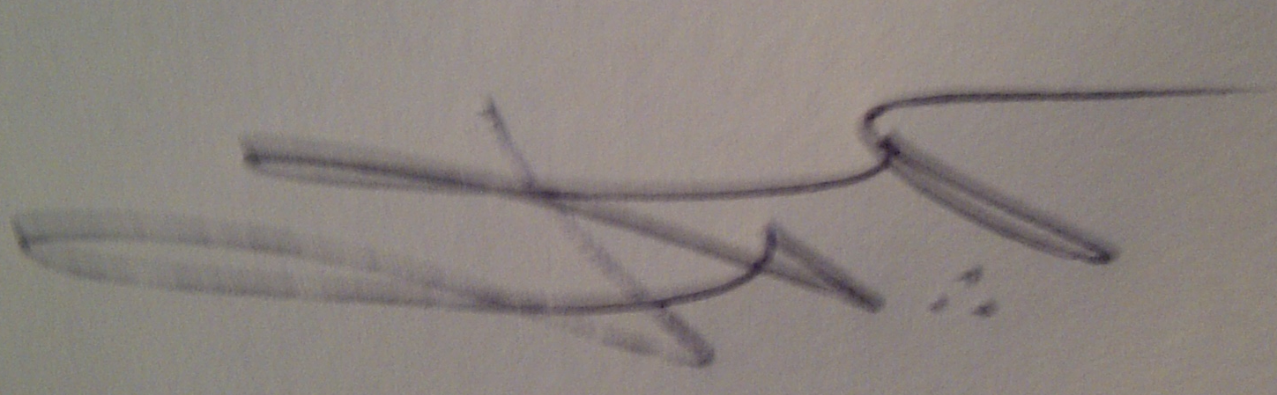
Alejo Neyeloff, PGM Ángel Jorge Clavero
Grand Secretary for Foreign Relations Grand Master

