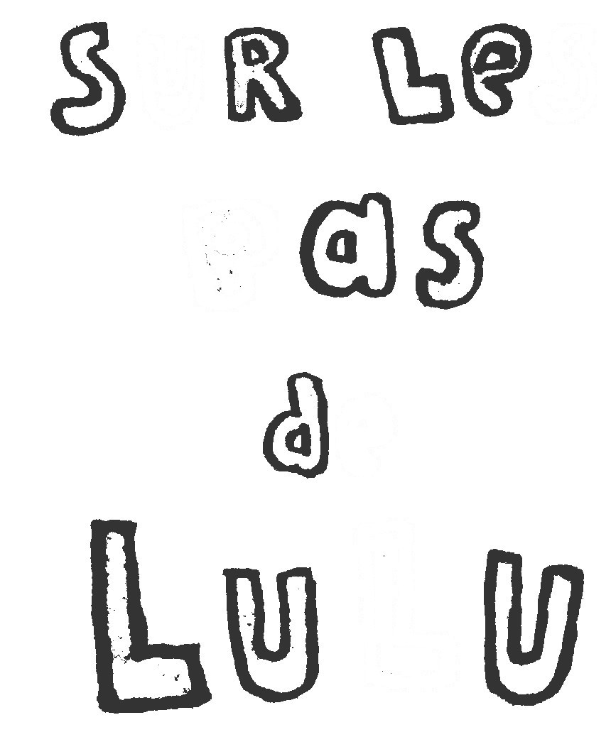

|  |  |  |  |  |
| --- | --- | --- | --- | --- |
| e.jpg | p.jpg | s.jpg | l.jpg | u.jpg |