LES YEUX DU CHAT

pupille

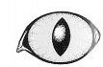

iris

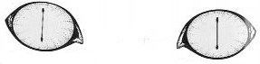

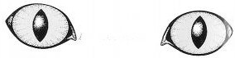

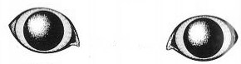

La pupille se dilate.

LES PATTES DU CHAT

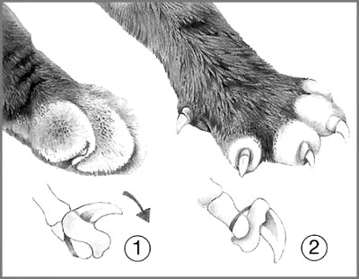

Les griffes du chat sont rétractiles.

|  |  |  |  |  |  |
| --- | --- | --- | --- | --- | --- |
|  |  |  |  | patte.bmppatte.bmp | griffures.bmp |

|  |  |  |  |  |  |
| --- | --- | --- | --- | --- | --- |
|  |  |  |  | patte.bmppatte.bmp | griffures.bmp |

|  |  |  |  |  |  |
| --- | --- | --- | --- | --- | --- |
|  |  |  |  | patte.bmppatte.bmp | griffures.bmp |

|  |  |  |  |  |  |
| --- | --- | --- | --- | --- | --- |
|  |  |  |  | patte.bmppatte.bmp | griffures.bmp |

|  |  |  |  |  |  |
| --- | --- | --- | --- | --- | --- |
|  |  |  |  | patte.bmppatte.bmp | griffures.bmp |

|  |  |  |  |  |  |
| --- | --- | --- | --- | --- | --- |
|  |  |  |  | patte.bmppatte.bmp | griffures.bmp |