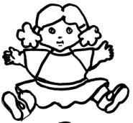  P p p | P p p | P p p | 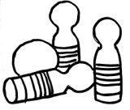  Q q q
Q q q | Q q q | 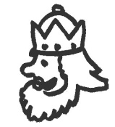  R r r | R r r
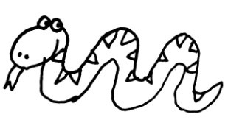  S s s | S s s | R r r | 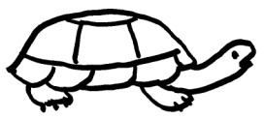  T t t
 | S s s | T t t | T t t
P p p | P p p | P p p | Q q q
Q q q | Q q q | R r r | R r r
S s s | S s s | R r r | T t t
 | S s s | T t t | T t t
P p p | P p p | P p p | Q q q
Q q q | Q q q | R r r | R r r
S s s | S s s | R r r | T t t
 | S s s | T t t | T t t

