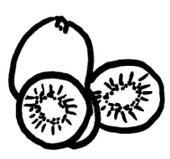  K k k | K k k | K k k | 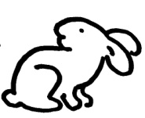  L l l
L l l | L l l | 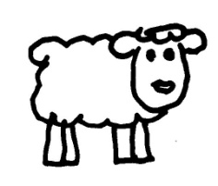  M m m | M m m
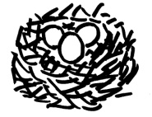  N n n | N n n | M m m | 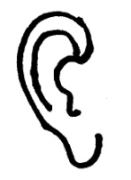  O o o
O o o | N n n |  | O o o
K k k | K k k | K k k | L l l
L l l | L l l | M m m | M m m
N n n | N n n | M m m | O o o
O o o | N n n |  | O o o
K k k | K k k | K k k | L l l
L l l | L l l | M m m | M m m
N n n | N n n | M m m | O o o
O o o | N n n |  | O o o

